**DEVOPS**

DevOps is a combination of Development and Operations, emphasizing teamwork between software developers and IT operations teams. It is not a single tool but a set of practices, processes, and cultural philosophies that aim to improve collaboration, automate repetitive tasks, and streamline software delivery.

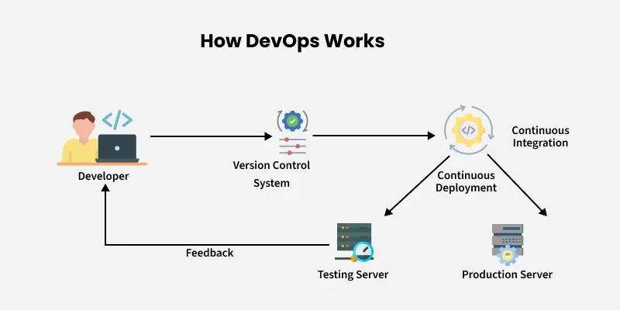The main goal of DevOps is to shorten the software development lifecycle while ensuring high-quality, stable, and secure software releases. It integrates people, processes, and technology to create a smooth and efficient software delivery pipeline.

KEY CONCEPTS:

**Continuous Integration (CI):**  
Developers regularly merge code changes into a central repository. Automated tests run every time new code is added, helping detect errors early.

**Continuous Delivery (CD):**  
Builds and tests are automatically deployed to production or staging environments, enabling rapid and reliable software releases.

**Infrastructure as Code (IaC):**  
Infrastructure like servers, networks, and databases are managed using code, reducing manual work and ensuring consistency across environments.

**Monitoring and Feedback:**  
Continuous monitoring of applications and infrastructure helps detect issues like performance bottlenecks or security vulnerabilities. Feedback from monitoring is used to improve future releases.

**Collaboration and Communication:**  
Teams work together using shared tools, dashboards, and processes. This reduces silos and ensures everyone is aligned on project goals.

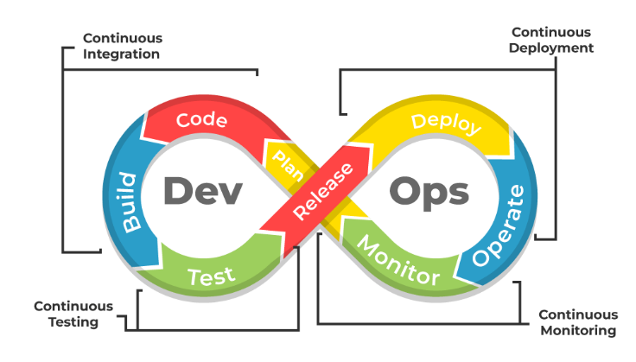

KEY DIFFERENCES:

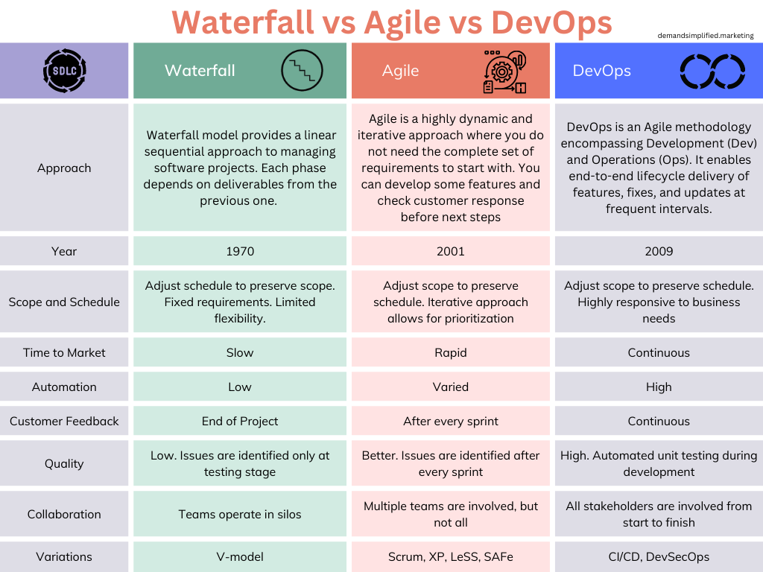

ADVANTAGES:

DevOps provides multiple benefits for organizations, developers, and customers. Some key advantages include:

* **Faster Time-to-Market:**  
  Automated build, test, and deployment pipelines allow software to be released more quickly.
* **Improved Collaboration:**  
  Developers and operations teams communicate and work together closely, reducing errors and misunderstandings.
* **Higher Quality Software:**  
  Continuous testing ensures that bugs and errors are detected early, resulting in more stable and reliable applications.
* **Increased Efficiency:**  
  Automation of repetitive tasks like testing, deployment, and monitoring saves time and reduces human error.
* **Scalability and Flexibility:**  
  Infrastructure as Code allows organizations to easily scale applications and manage multiple environments efficiently.
* **Better Customer Satisfaction:**  
  Faster, reliable software releases mean that user feedback can be implemented quickly, improving overall user experience.
* **Continuous Improvement:**  
  Monitoring and feedback loops provide insights that help improve software performance, features, and security over time.